Repair an Outlook data file (.pst) file
- Exit Outlook and browse to one of the following file locations:
  - Outlook 2016: C:\Program Files (x86)\Microsoft Office\root\Office16
  - Outlook 2013: C:\Program Files (x86)\Microsoft Office\Office15
  - Outlook 2010: C:\Program Files (x86)\Microsoft Office\Office14
  - Outlook 2007: C:\Program Files (x86)\Microsoft Office\Office12
- Open SCANPST.EXE.
- Select Browse to select the Outlook Data File (.pst) you want to scan. If you need help locating your Outlook Data File, see Locating the Outlook Data Files.
Note: By default, a new log file is created during the scan. You can choose Options and opt not to have a log created, or you can have the results appended to an existing log file.
- Choose Start to begin the scan.
- If the scan finds errors, choose Repair to start the process to fix them.
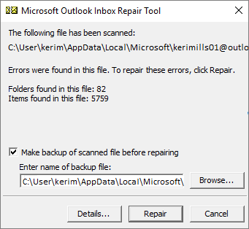
Note: The scan creates a backup file during the repair process. To change the default name or location of this backup file, in the Enter name of backup file box, enter a new name, or choose Browse to select the file you want to use.
- When the repair is complete, start Outlook with the profile associated with the Outlook Data File you just repaired.

